Gruppo di Interesse SIDI  in Bioetica e Biodiritto  Internazionale ed Europeo | 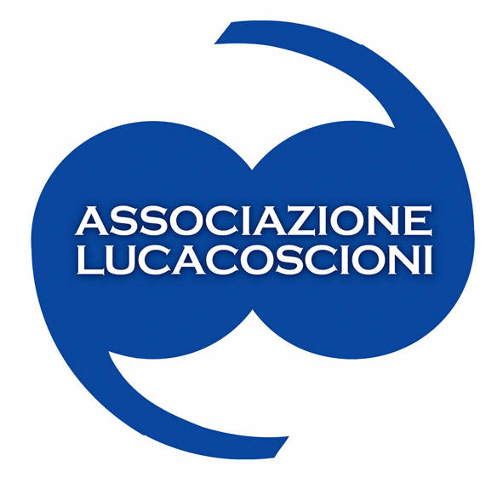 | 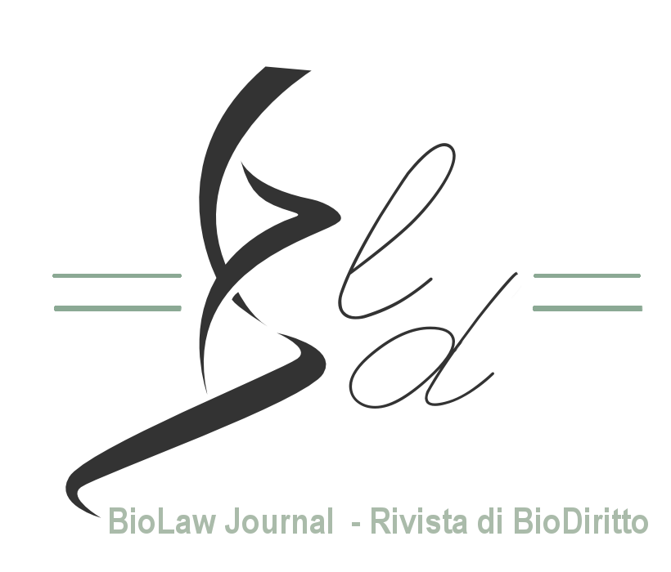

Call for abstracts

Right to enjoy the benefits of science and freedom of research

Workshop session within the International Conference on ‘Right to science and freedom of research on narcotic and psychotropic substances’, organized by Associazione Luca Coscioni (ALC) and hosted by the University of Turin (UNITO)

28-29 September 2017
Campus Luigi Einaudi - Torino
------------------------------------

On the occasion of the fourth meeting of the G7 Ministers of Science and Technology in Turin, UNITO will host the conference organized by Associazione Luca Coscioni on ‘Right to science and freedom of research on narcotic and psychotropic substances’.

Within this context, the Interest Group on Bioethics and International and European Biolaw of the Italian Society of International and EU Law (SIDI-ISIL) and the Biolaw Project of the University of Trento co-sponsor an international and interdisciplinary workshop on ‘Right to enjoy the benefits of science and freedom of research’. Abstract submissions are invited for consideration.

Overview of the ALC Conference
Right to science and freedom of research on narcotic and psychotropic substances

The purpose of the conference organized by Associazione Luca Coscioni is twofold, as it will address both legal and scientific profiles of the right to science and the freedom of research, with special reference to narcotic and psychotropic drugs and their therapeutic application.

Firstly, the conference aims at exploring the notion of ‘right to science’, both as the right to enjoy the benefits of scientific progress and its applications, especially as regards health, and the freedom of research at the benefit of scientists. In particular, the conference will consider legal implications for the right to science deriving from the UN Drugs Control Conventions (the Single Convention on Narcotic Drugs, 1961, as amended by the 1972 Protocol; the Convention on Psychotropic Substances, 1971, and the Convention Against Illicit Traffic in Narcotic Drugs and Psychotropic Substances, 1988) and their implementation in domestic legal systems.

Secondly, the conference intends to provide updates on recent clinical trials on substances under the international drug control regime. In addition, a specific session of the conference will be entirely devoted to explore new finding on the therapeutic application of narcotic and psychotropic substances.

Confirmed speakers include:

- Tom Blickman, Transnational Institute, Amsterdam
- Andrea Boggio, Bryant University, Boston
- Tracey Brown, Sense About Science, London
- David Erritzoe, Imperial College, London
- Amanda Feilding, Beckley Foundation, London
- Natalie Ginsberg, Multidisciplinary Association for Psychedelic Studies, Santa Cruz
- Christopher Hallan, International Drug Policy Consortium, London
- Jordi Riba, Sant Pau Institute of Biomedical Research, Barcelona
- Cesare Romano, Loyola University, Los Angeles
- Mario Simoes, Olga Duarte Silva and Sofia Machado Ferreira, Faculty of Medicine and Pharmacy, Lisbon

Scientific Committee of the Conference:

Marco Perduca & Filomena Gallo (Associazione Luca Coscioni)
Tania Re (UNESCO Chair “Antropology of Health, Biosphere and Healing Systems”, University of Genoa)
Cesare Romano (Loyola University, Los Angeles)

Workshop and call for abstracts
Rights to enjoy the benefits of science and freedom of research

The Workshop is co-sponsored by the Interest Group on Bioethics and International and European Biolaw of the Italian Society of International and EU Law (SIDI-ISIL) & the Biolaw Project, University of Trento.

The Workshop will complement the ALC conference with the aim of discussing the existence of a common core of the right to science and freedom of research at the international level and the role of international and national institutions in guaranteeing such freedom.

Proposals are welcomed on topics related to the main themes of the ALC conference, including, but not limited to:
- international, EU and comparative law issues connected to the right to science in general and its relation with other fundamental rights - primarily, but not exclusively - the right to health;
- the existence of common standard of protection at the international level, particularly focussing on the role of courts and agencies;
- the existence of a common constitutional ground at the national level for the freedom of research and its relationship with other constitutional goods (right to health, public order);
- especially sensitive issues, in which the relationship between freedom of research and other constitutional goods is particularly challenging (for example: the research over embryos and embryonic stem cells);
- the nature of state obligations under the UN Drug Control Conventions and their intersections with other treaty regimes, such as human rights, (and ICESCR in particular), indigenous people rights or the UN Convention on biodiversity and the UN Sustainable Development Goals;
- the role of the Commission on Narcotic Drugs (CND), the UN Office on Drugs and Crime (UNODC) the International Narcotics Control Board (INCB), and the World Health Organization (WHO) as well as UNDP and UNAIDS;
- possible tensions between national policy practices and the treaty framework, especially in the area of cannabis regulation.

Scientists and researchers are also invited to submit proposals:
- to provide updates on current international clinical trials on psychotropic substances;
- to describe new finding on the therapeutic application of narcotic and psychotropic substances;
- to explain, through their direct experience, how regulations might impact on research.

Abstracts submission procedure

Interested participants should provide an abstract (either in Italian or in English) of no more than 500 words by 15 August 2017 to biodiritto@gmail.com, including name, institutional affiliation and a brief CV.

Presentations should be no longer than 20 minutes in duration. Speakers will be informed of acceptance of their papers by the 1st of September and will be expected to submit either a full or outline paper by the 20th of September.

The most interesting papers will be also considered for a possible publication in a special issue of Biolaw Journal.

Scientific Committee of the Workshop

Ludovica Poli & Adriana Di Stefano (SIDI Interest Group on Bioethics and International and European Biolaw)
Simone Penasa, Lucia Busatta, Marta Tomasi & Elisabetta Pulici (Biolaw Project, University of Trento)
Tania Re (UNESCO Chair “Antropology of Health, Biosphere and Healing Systems”, University of Genoa)

